**How Graduate Computing Students Search When Using an Unfamiliar Programming Language**

[*Gina Bai*](https://conf.researchr.org/profile/icpc-2020/ginabai), [*Joshua Kayani*](https://conf.researchr.org/profile/icpc-2020/joshuakayani), [*Kathryn Stolee*](https://conf.researchr.org/profile/icpc-2020/kathrynstolee)

[ICPC 2020 Research](https://conf.researchr.org/track/icpc-2020/icpc-2020-research)

**Introduction**:

Students of development and computing are generally expected to excellent in numerous programming languages. To gain proficiency with another dialect, developers regularly go to online search to find data and code. Research on code search conduct commonly includes checking developers during search exercises through logs or reviews. They led an investigation on how computing learners scan for code in an unfamiliar programming language with 18 graduate students working a shot at VBA tasks in a lab situation .By examining the blend of search logs and overview reactions, we found that the students ordinarily search to investigate APIs or discover model code. Around half of inquiries that go before taps on documentation or instructional exercises effectively tackled the issue. Students much of the time acquired terms from languages with which they are natural while scanning for models in an unfamiliar language. These outcomes have suggestions for code search research, particularly on reformulation, and for research on supporting programmers when learning another new language. They developed a Google Chrome extension that records search events and browsing history and deploys surveys. They had done log analysis on combined survey responses. Developers have the ability to do frequently turning to code search to find code examples to learn from and improve their productivity during development activities. Studies on code search in software engineering seek to understand how and why developers search when performing their daily work introduce new code search tools or propose potential improvement of existing code search tools and suggest effective code search strategies .The code search examines are regularly acted in the wild, so to observe developers during their typical movement.

**METHODOLOGY**:

Their methodology includes logging search and browser exercises and occasionally looking over participants about their flow tasks, like earlier work .However, not at all like earlier work, which is controlled by expressly inquiring as to whether a hunt was effective. Earlier human studies with code search don't show what elements lead to effective hunts, in enormous part in light of the fact that acquiring proof of search achievement is precarious. in any case, not successful ones. where appropriate, parallels are drawn between the learners in our study and professional developers from a similar study at Google. While the contexts of the studies varied widely (i.e., normal developer workflow with Google Developers vs. a lab study with students working with an unfamiliar language).They grouped the logs by participants’ IDs and sorted them by log time. Surveys were tabulated and associated with browser events for analysis. Logs were analyzed to collect 1) search queries, 2)ordered list of clicked website URLs associated to each query, and3) time spent by a participant on a clicked result page .The logs were part into search meetings. Because of our study setting, embracing the meaning of a pursuit meeting from the studyon Google developers was risky. While thinking about a search meeting as a progression of designer exercises isolated by 6- minutes of inertia, every member in our study had precisely one search meeting. In this way, we treat each search question and its partner search meeting. In this way, we treat each search question and its partner result clicks as one pursuit meeting (alluded to as "small scale meeting" in earlier work. The center around related work that examines code search practices, investigates end-clients' commitment with spreadsheets, and talks about the learning obstructions in programming frameworks .Learning barriers in programming systems can arise from the environment and accompanying libraries observed that learners sometimes knew what set of interfaces could achieve a behavior, but did not know how to use and coordinating them .The use and co-ordination barrier sare hard to overcome without well-written documentation and code examples. Prior studies point out that it is essential for API documentation to provide developers, especially those who are trying to learn particular API, with sufficient and adequate code examples. These studies echo our findings that of the issues that students experienced were effectively fathomed by finding significant Programming interface and code executions.

**Conclusion or result:**

We concentrated how graduate students search when illuminating programming errands in another dialect. We locate that ensuing programming language students search with the reasons for investigating for model code, structuring new highlights and understanding why code proceeds as it does. Students created more verbose queries, and required longer an ideal opportunity to look over the query item than proficient developers did. Counseling partners/companions face to face could improve the opportunity to tackle an issue. Counseling documentation and instructional exercises is more demonstrative of success in a pursuit than counseling Q&A locales. Queries that emphasis on how something functions are bound to succeed when being formed with the structure, “*How to do...* ”. Learns frequently borrowed terms from languages with which they are familiar when searching for examples in an unfamiliar language. The term obtaining queries were almost certain to success than the run of the mill question by and large. According to the search objectives, map APIs between programming languages and present sample code are suggested to support more programming languages .

**Paper # 2:**

Evaluating a Visual Approach for Understanding JavaScript Source Code:

[*Martín Dias*](https://conf.researchr.org/profile/icpc-2020/martindias), [*Diego Orellana*](https://conf.researchr.org/profile/icpc-2020/diegoorellana), [*Santiago Vidal*](https://conf.researchr.org/profile/icpc-2020/santiagovidal), [*Leonel Merino*](https://conf.researchr.org/profile/icpc-2020/leonelmerino), [*Alexandre Bergel*](https://conf.researchr.org/profile/icpc-2020/alexandrebergel)

[ICPC 2020 Research](https://conf.researchr.org/track/icpc-2020/icpc-2020-research)

**Introduction:**

Software developers collaborate with standard programming conditions basically through literary components. Regularly, auxiliary components, including files, classes, and packages, are introduced as

an expandable rundown gadget on the left-hand side of the IDE and the substance of a chose component is shown in the middle as a enormous printed board. visualization is known to be effective at helping specialists in completing software perception and maintenance tasks .Hunter, a tool for the visualization of JavaScript applications. Hunter visualizes source code through a set of coordinated views that include a node-link diagram that depicts the dependencies among the components of a system, and a tree map that helps programmers to orientate when navigating its structure. Our prototype of such an IDE augmentation is called Hunter. Hunter is useful to navigate, analyze, and comprehend JavaScript applications. Its intended to help developers in the procedure of software perception. For instance, Hunter permits developers to rapidly portray the important structures of a software framework and their conditions. Hunter helps to numerous connections to show detailed data on request. Hunter programmers required significantly less time to complete various software comprehension tasks and achieved a significantly higher accuracy .Our analyses demonstrate that utilizing the perceptions provided by Hunter incredibly diminishes the time required by developers to lead some software perception undertakings when contrasted with classical IDEs. Along this line, the principle commitments of this paper are Hunter and an intensive assessment of it from different points of view.

**METHODOLOGY:**

Its graphical interface is composed of five panels. The left-most one (FB) is a File Browser,  
present in most IDEs. On the figure, the file index.js is selected .The panel in the center is the File Dependencies View (V), which represents dependencies between JavaScript source code files. The top-right panel (O) gives the file Outline that shows the structure in terms of functions nesting of a selected file. In the example, a function has been selected by the user .The left-bottom panel (S) is a Search box that can be used to identify specific files or functions in V. Finally, the right-bottom panel (SC) shows the Source Code of a selected file .**File Outline View:** The plot is a tree map visualization strategy, which utilizes a lot of nested tiles to speak to progressive structures. The plot speaks to the JavaScript capacities and classes denied in a chosen file. The size of the auxiliary components is spoken to by the size of the tiles of the tree map. We utilized a tree map on the grounds that it was indicated that this visual procedure is effective at speaking to the internal and progressive structure of a JavaScript file . **interactivity:** While choosing a file, in the file program or the file reliance see, the file is featured with a thick cyber border. Active and approaching conditions are featured in blue and red separately. These associations can be utilized by software engineers to investigate software measurements, for example, fan-in, fan-out and identify segments that, for example, should be re-factored**.**

METHODOLOGY: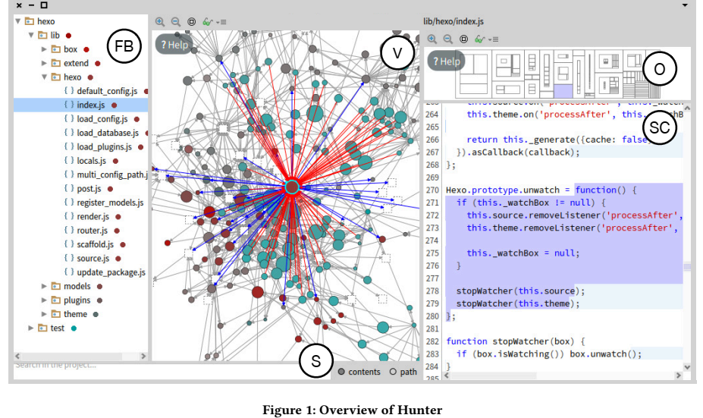

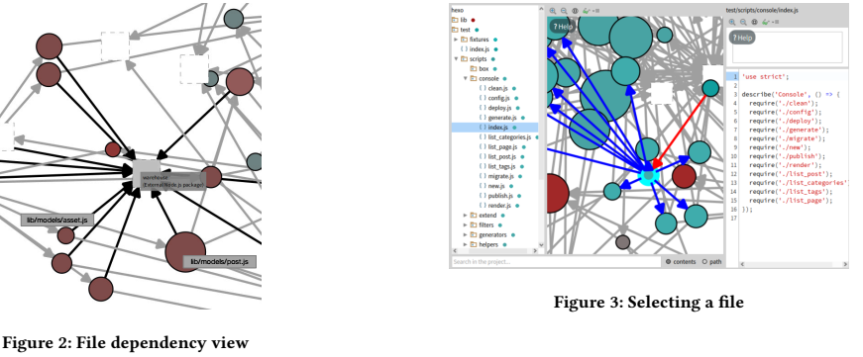

The goal of our experiment is to measure and characterize the impact of using Hunter’s visualizations to support some representative code comprehension tasks. Consequently, we designed a controlled user experiment to analyze the effectiveness of developers that use Hunter compared to a baseline framework, Visual Studio Code7 (VSC), a popular IDE used for the development of JavaScript software systems.

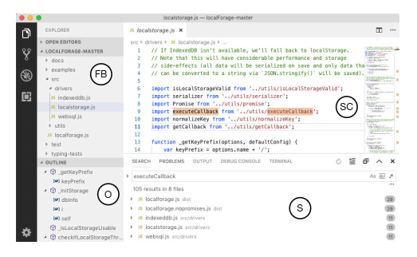

**Overview of visual studio code(VSC)**

**Conclusion or result**:

In this research, we introduced Hunter, a visualization approach that supports developers on software cognizance undertakings to understand JavaScript applications .The survey the benefits of Hunter, we directed an exhaustive controlled examination driven by five research questions. Altogether, 16 software developers took part in our experiments with a proper background and experience. We request that every member illuminate nine undertakings utilizing Visual Studio Code and utilizing Hunter. We found that when utilizing Hunter, developers can build their client execution regarding their precision to solve software understanding assignments. also, the time that they have to perform such tasks Specifically, we found that from nine tasks, the middle of the rightness of developers' answers when utilizing Hunter was eight against just six and a half when utilizing Visual Studio Code. With respect to culmination time, we found that the middle of the time spent for members utilizing Hunter is 393 seconds against 1,386 of Visual Studio Code. In addition, we found that members expected to utilize less boards in Hunter than in Visual Studio Code. On account of client experience, we found that developers feel, as a rule, positive feeling when utilizing Hunter and that they feel that the apparatus is valuable….

Paper # 3

**Knowledge Transfer in Modern Code Review**

[Maria Caulo](https://conf.researchr.org/profile/icpc-2020/mariacaulo), [Bin Lin](https://conf.researchr.org/profile/icpc-2020/binlin1), [Gabriele Bavota](https://conf.researchr.org/profile/icpc-2020/gabrielebavota), ,[Giuseppe Scanniello](https://conf.researchr.org/profile/icpc-2020/giuseppescanniello),, Michele Lanza

**Artifacts at**[**ICPC**](https://conf.researchr.org/room/icpc-2020/virtual-venue-icpc)

**Introduction:**

The code review process also referred to as peer review, stands out as a tried and tested method in a large palette of applications to allow for the systematic examination of software source code. It's conducted to find bugs and improve the overall quality of the software. Knowledge transfer is one of the main goals of modern code review ,as shown by several studies that surveyed and interviewed developers. While knowledge transfer is a clear expectation of the code review process, there are no analytical studies using data mined from software repositories to assess the effectiveness of code review in “training” developers and improve their skills over time. Most of these studies are qualitative in nature , and were conducted by surveying/interviewing developers or by inspecting their conversations  
in mailing lists or issue trackers of open source projects. Only a few researchers analyzed data from a quantitative perspective, mostly toassess the impact of code review on code quality (e.g., the relationship between code review and post-release defects).The primary purpose of code review is to make sure that the overall code health of Google's code base is improving over time. All of the tools and processes of code review are designed to this end. In order to accomplish this, a series of trade-offs have to be balanced.

**Hypothesis:**

Software development and the Programming advancement is a knowledge-serious movement. Subjective examination gave evidence that code review plays a vital job in knowledge move among developers. Be that as it may, no quantitative evidence exists on the side of this case. In this investigation ,we mine product archives to quantitatively evaluate the knowledge move happening on account of code review .

There is no settled measurement to survey the "amount of knowledge" engaged with a given procedure. Knowledge can be named either express (which "can be spoken and classified in words, figures or symbols") or unsaid (which "is implanted in people's minds and is difficult to communicate and communicate to other people").They center around the implicit knowledge gained by developers after some time, which can't be handily observed and evaluated. All the more explicitly, we research whether the experience picked up by accepting feedback during code review improves the nature of developers' future commitments to open source projects. Naturally, one may anticipate that developers steadily gain knowledge by accepting criticism from their friends, in this manner improving their aptitudes after some times.

**DATA ANALYSIS:**Our hypothesis suggests that developers, who benefited of higher knowledge transfer thanks to the past reviewed PRs they submitted ,are also the ones contributing higher quality PRs in the project .We verify this hypothesis thanks to the data previously extracted :Each peer-reviewed submitted by any of the studied developers presents a row in our dataset, reporting (i) the knowledge transfer measures, meaning the number of past reviewed PRs performed by the developer before as well as our control variable, represented by the number of commits she performed in the past.

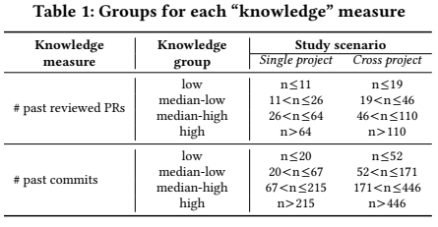

In particular, the top part of each figure reports the results obtained when splitting developers into “knowledge groups” based on the past reviewed PRs they submitted, while the bottom part shows the same results when grouping developers based on the number f past commits they performed. The red dot represents the mean value in each box plot.

**Conclusion or result:**

They introduced a quantitative report to research knowledge move in code review. Our outcomes were for the most part negative: we couldn't to catch the positive pretended by code review in knowledge move among developers, as was recently recommended in the writing. This came to us as a surprise, as we were confident tosee at least significant traces of the knowledge transfer, we really are persuaded that their cases are right. This brings up various issues that we have tended to in part all through the last piece of the paper, where we guess potential errors in our analysis plan and remarkable dangers to legitimacy that are hard to completely address, particularly those in regards to the measures we used to evaluate the effect of knowledge transfer. We stress the way that our discoveries don't repudiate past subjective outcomes announced in the writing, but instead require extra examinations planned for seeing how (and on the off chance that) we can in reality catch the knowledge move in code review in a quantitative way. Consequently, our principle heading for future work incorporates extra examinations exploring a similar exploration inquiries with an alternate test structure. In particular, we will examine which measures can be utilized as an exact intermediary to speak to the knowledge transfer, in both quantitative and subjective way. The information utilized in our examination is openly accessible.